Digital Design and Technology Support Centres
‘Digital D&T’ is the new programme funded by the Department for Children, Schools and Families (DCSF), which builds on and grows out of the two major curriculum development projects - CAD/CAM in Schools and the Electronics in Schools Strategy.

Over a 3 year period the objective of the programme is to continue the development of support for both CAD/CAM and ECT, and to consolidate that support into a more coherent package to reflect the changing requirements of the curriculum at Key Stage 3, the 14-19 curriculum (including the Engineering Diploma) and the STEM agenda.

The Design and Technology Association will manage the programme which is to be funded for the next 3 years (2008-11). This will involve setting up 36 support centres across the country which will help drive the programme forward by providing local advice and through both discrete and collaborative working across CAD/CAM and ECT.
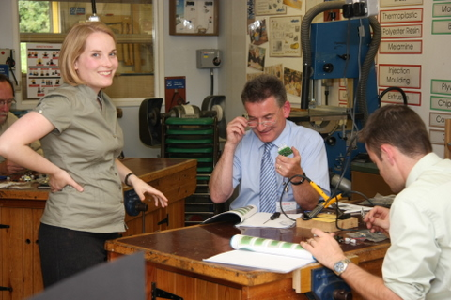
NTU Digital Design and Technology Support Centre
Working in partnership with: Nottinghamshire Setpoint and Nottinghamshire Local Authority and ASTs

The NTU Centre for Design and Technology Education has been designated a DDTSC for the East Midlands and will act as a fully integrated ECT, CAD/CAM centre building on its established reputation as a leading EiSS Hub. The focus of activity will be directed towards curriculum innovation embracing the latest technologies within, Electronics, CAD/CAM and Textiles. This will be promoted and developed through our initial teacher training programmes, CPD for practising teachers and school awareness events.

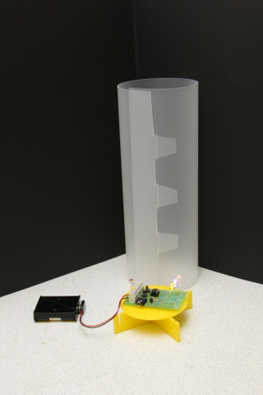

To register for a meeting or course contact:
Julie Ferrigan Julie.ferrigan@ntu.ac,uk Tel: 0115 848 6161

For further information contact:
Andy Cooper NTU, ECT CAD/CAM andy.cooper@ntu.ac.uk Tel: 0115 848 2666
Sarah Davies NTU, Textiles CAD/CAM sarah.davies@ntu.ac,uk Tel: 0115 848 2644
Jacqui Aram NEBA Stempoint j.aram@neba.org.uk Tel: 0162 345 3404
Phil Drabble Nottinghamshire LA phil.drabble@nottscc.gov.uk Tel: 0162 343 4136


